Tool #: Select_Links1_SMART-Goals
Step: Select
Type: Helpful Links
Format: Table of hyperlinks
Purpose/Main Objective(s): To provide links that will help the user write good goals and SMART objectives that will be helpful when selecting an EBP.
Performance/Change Objectives (list): (to be filled in at a later date if necessary)
Target Audience(s)/Likely Users: SHAC members; School principals, teachers, and school health coordinators
References the following other tools:
- Select_Step Overview
Description/Script/Audio: Links with descriptions of the link and how it will be helpful for the user in writing good goals and SMART objectives.
This page will contain a thumbnail screenshot of each link, the title of each link, and a brief description of each link and what information and resources they will find when they click on that link.
On-screen script:
“This page contains various links to help you learn about good goals and SMART objectives and how to write them. Visit the Select Step Overview to learn why creating goals and objectives is important.”

Thumbnail or Logo | Text
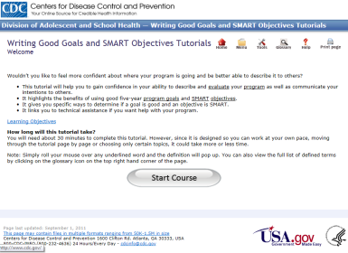 | Writing Good Goals and SMART Objectives Guide  This is a website presented by the Centers for Disease Control and Prevention (CDC) on writing concise and through goals and objectives that are SMART (Specific, Measurable, Achievable, Relevant, Time-Bound). You may want to consider reviewing this comprehensive guide as your first step in learning about SMART goals and objectives.  https://www.cdc.gov/dhdsp/evaluation_resources/guides/writing-smart-objectives.htm
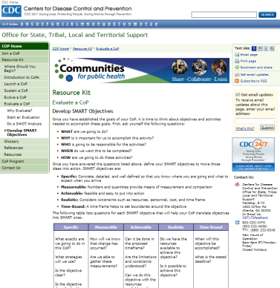 | SMART Objectives Template  Download this “SMART Objectives Template” from the Centers of Disease Control to quickly develop your own SMART (Specific, Measurable, Achievable, Realistic, Time-Bound) objectives.  http://www.cdc.gov/phcommunities/resourcekit/evaluate/smart_objectives.html
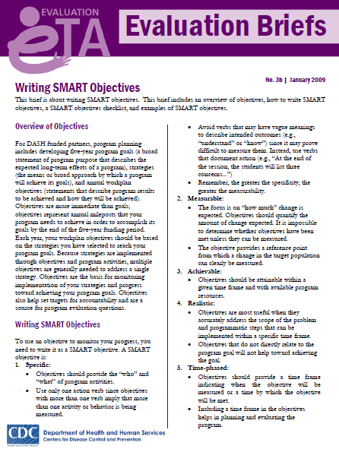 | Writing Smart Objectives  This resource includes a brief overview of SMART objectives, a SMART objective checklist, and examples of SMART and non-SMART objectives.  http://www.cdc.gov/healthyyouth/evaluation/pdf/brief3b.pdf
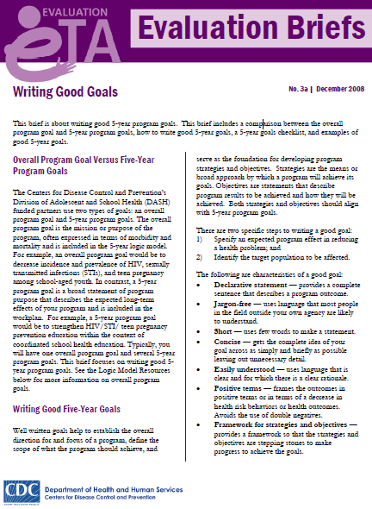 | Writing Good Goals  This resource gives a brief overview of 5-Year Program Goals, the difference between a 5-Year Program Goal versus an overall program goal, and a checklist for writing 5-Year Program Goals.  http://www.cdc.gov/healthyyouth/evaluation/pdf/brief3a.pdf
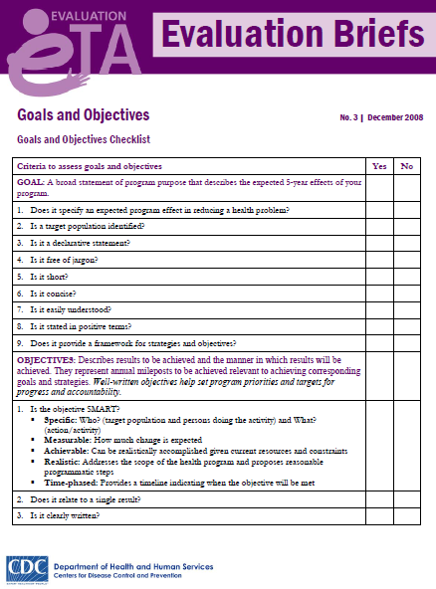 | Goals and Objectives Checklist  This checklist will help you determine whether the goals and objectives you make meet the criteria for good goals and SMART objectives.  http://www.cdc.gov/healthyyouth/evaluation/pdf/brief3.pdf

