Stakeholder Analysis Template

How to complete the template:
Column 1: List the name, title/role in the district, and contact information of each stakeholder who would be involved in the planning or implementation of the evidence-based program in each row.

Column 2: Decide if each person identified in column 1 has a primary or secondary role in the decision-making process. Those with primary roles are individuals with decision-making authority related to the issue. Those with secondary roles are individuals that can influence those with primary roles.

Column 3: Estimate the level of knowledge about the issue for each person identified in column 1. Each person can have a high level of knowledge or know very little about the issue. Understanding their level of knowledge will help you determine how much information you may need to present when discussing your issue. If you are unsure about their level of knowledge, assume he/she knows very little about the issue when you first meet with him/her.

Column 4: Estimate the degree to which each person identified in column 1 is in agreement with the issue. Are they supportive, opposed, or neutral about the issue? If you are unsure, it may be helpful to connect with other district staff members who are more familiar with the stakeholder to try to determine his/her degree of agreement.

Column 5: List any potential benefits or risks to each person identified in column 1 if they support the issue. Examples of potential benefits include: seen favorably by administrators and parents in the district, seen as an innovator, potential to build the district’s resources. Examples of potential risks include: seen unfavorably by administrators and parents, risk of losing re-election to school board, and risk of not having other staff support to help with implementation.

Column 6: List the primary action you would like each person identified in column 1 to take. This could be as simple as meeting with you again at a later date or joining the school health advisory council (SHAC) to something much larger such as supporting a new evidence-based program.

Column 7: List at least two alternative actions you would like each person identified in column 1 to take if they reject your primary action. Alternative actions are the next best action to which you can both agree. Examples include having a follow-up meeting to discuss concerns, reviewing material that you have provided, or talking to other district staff to discuss concerns.

Example:
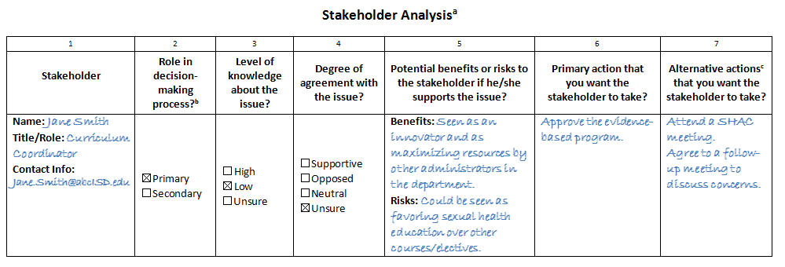

Stakeholder Analysisª

1 | 2 | 3 | 4 | 5 | 6 | 7
Stakeholder | Role in  decision-making process?^{b} | Level of knowledge about the issue? | Degree of agreement with the issue? | Potential benefits or risks to the stakeholder if he/she supports the issue? | Primary action that  you want the  stakeholder to take? | Alternative actions^{c} that you want the stakeholder to take?
Name:  Title/Role:  Contact Info: | ☐ Primary  ☐ Secondary | ☐ High  ☐ Low  ☐ Unsure | ☐ Supportive  ☐ Opposed  ☐ Neutral  ☐ Unsure | Benefits:  Risks:
Name:  Title/Role:  Contact Info: | ☐ Primary  ☐ Secondary | ☐ High  ☐ Low  ☐ Unsure | ☐ Supportive  ☐ Opposed  ☐ Neutral  ☐ Unsure | Benefits:  Risks:
Name:  Title/Role:  Contact Info: | ☐ Primary  ☐ Secondary | ☐ High  ☐ Low  ☐ Unsure | ☐ Supportive  ☐ Opposed  ☐ Neutral  ☐ Unsure | Benefits:  Risks:
Name:  Title/Role:  Contact Info: | ☐ Primary  ☐ Secondary | ☐ High  ☐ Low  ☐ Unsure | ☐ Supportive  ☐ Opposed  ☐ Neutral  ☐ Unsure | Benefits:  Risks:
Name:  Title/Role:  Contact Info: | ☐ Primary  ☐ Secondary | ☐ High  ☐ Low  ☐ Unsure | ☐ Supportive  ☐ Opposed  ☐ Neutral  ☐ Unsure | Benefits:  Risks:
ª Adapted from Family Care International. Mobilizing Communities on Young People’s Health and Rights: An Advocacy Training Guide. 2008.
^{b} Primary: Individuals with the decision-making authority related to the issue. Secondary: Individuals that can influence stakeholders in primary roles.
^{c} Alternative actions are potential actions you want the stakeholder to take if the primary action is not feasible.

