Stakeholder Analysis Templateª
Get Support: This is a resource that can help you identify community partners and key decision-makers that can help support the delivery and implementation of your sexual health program. These partners may have resources or contributions beyond what you can think of, so stay open to learning about what they are doing and how they want to work together.
Instructions: In the left column, brainstorm potential and existing partners that can support your work. Include actual names or organizations, if you know them. There are a few categories written in to get you started and a few “Other” spaces that can be used for partners that don’t fit into the other boxes. In the right column, list ways these partners can support or participate in your programming.
Who Can Support the Program? How Can They Support the Program?
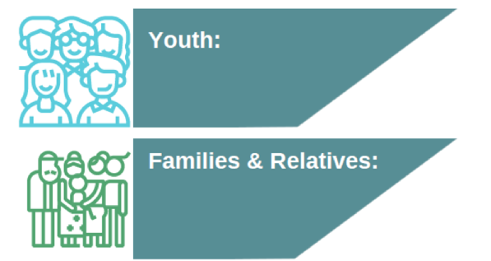
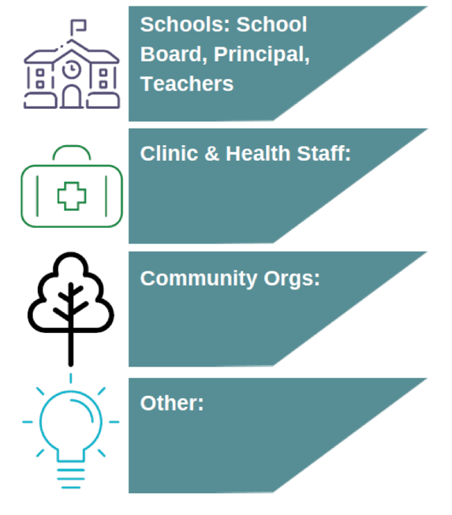

ª Adapted from Trevino, N., & Gaston, A. 2020. Healthy Native Youth: Virtual Adaptation Guide. Portland, OR: Northwest Portland Area Indian Health Board. Section 2.1 Identifying & Building Partnerships.

