UTHealth SPH Guidelines for Conduct of Community-based Research
During the COVID-19 Pandemic
June 21, 2020

The purpose of this document is to provide recommendations and guidance for Principal Investigators (PI), Investigators, and Project Coordinators engaged in community-based research during the COVID-19 pandemic. These guidelines pertain to health and safety management protocols with regard to all research staff and study participants. This document is based on COVID-19-related best practices and recommendations, including those from UTHealth, The University of Texas at Austin, the Centers for Disease Control and Prevention, OSHA, and Johns Hopkins University & Medicine.
These recommendations are based on two overarching principles: (1) concern for the safety of research staff and research participants; and (2) robust and significant community-based research.
This document promotes research in compliance with current CDC guidelines – as such, this document should be regularly updated to reflect the most updated research and best practices.
Additional resources are provided at the end of the document.
This document is laid out with 9 overall considerations for community-based research, including training, density reduction, symptom surveillance, personal protection, environmental maintenance, screening and testing, project management, communication, research and study design, and special considerations. A summary at the beginning states the essential elements for consideration to resume community-based research. Note that each research project is unique, and might need additional precautions or accommodations. This document is not intended to cover all situations, but rather to serve as overall guidance that can be customized to the individual research project. Ultimately, it is the study PI who must oversee and take responsibility for the safety of the research team, the study participants, and the community-based setting

Summary of Investigator Actions Needed to Conduct Research with the COVID-19 Pandemic
- Follow standard recommendations where applicable. This include UTHealth guidance; state-, county-, and city-level rules; Centers for Disease Control and Prevention (CDC) recommendations; OSHA recommendations; and any guidance specific to the community setting (e.g., Texas Education Agency (TEA) for schools).
- Prepare for community-level research with COVID-19. Preparations include: staff preparation/training, assessment of staff risk, modification to protocols, obtaining personal protective equipment (PPE).
- Assess risk level in the community and for study participants. Entry into the community and staff/research preparation will depend on the current level of community transmission, as well as the setting (e.g., school, childcare center, long-term care facility, prison, etc.).
- Communicate frequently with research staff, community partners, and appropriate UTHealth departments (e.g., Committee for the Protection of Human Subjects, etc.).
- Document the process.

Overall considerations:
- Training
- Initial staff training
- All research staff should be trained on:
  - COVID-19 transmission and safety protocol including proper use of facemasks, social distancing, hand washing, surface disinfection, etc.
  - Minimization of transmission while conducting research with participants
  - COVID-19 information relevant to study site (number of cases in area, reported cases onsite (e.g., at a clinic or health center), etc.)
  - Training should be documented (e.g., date and time) by the project. Training should be completed prior to staff going into the field.
- Research staff should be trained on specifics of project data collection and proper procedures for interacting with participants to keep both themselves and the participants safe.
- Research staff should be trained to assess study site layout, specific rooms/areas where data collection will occur, which entrances/exits and restrooms will be used, which areas (if any) are off limits, etc., for any safety or potential transmission issues.
- Consider simulating active COVID-19 cases in research projects and deployment of protocol.
- Examples of training for the research staff.
  - Example of a general COVID-19 training: Johns Hopkins training, see https://coronavirus.jhu.edu/covid-19-basics/understanding-covid-19
- Supervisors and research staff should have some basic training on hazards at research sites, and identifying risks of worker exposure.
  - Classifying risk in employees (https://www.osha.gov/SLTC/covid-19/hazardrecognition.html) and Figure 1.
    - Lower exposure risk (caution) – jobs that do not require contact with people known to be, or suspected of being, infected with SARS-CoV-2. Workers have minimal occupational contact with the public and other coworkers.
      - Examples: Remote workers (working from home), office workers without frequent contact
      - Guidance:
        - Remain aware of community transmission
        - Social/physical distancing, masks, other general precautions
    - Medium exposure-risk - jobs that require frequent/close contact with people who may be infected, but who are not known to have or suspected of having COVID-19. Most community-based studies belong in this category.
      - Examples: those who have contact with the general public (e.g., in schools, high population density work environments, and some high-volume retail settings), those with contact with travelers, organized sports or choirs (might be high exposure risk depending on the sport)
    - High exposure risk – jobs with a high potential for exposure to known or suspected sources of SARS-CoV-2.
      - Examples: healthcare delivery and support staff, medical transport workers, mortuary workers, long-term care facilities, prisons
    - Very high exposure risk – jobs with a very high potential for exposure to known or suspected sources of SARS-CoV-2
      - Examples: healthcare workers, healthcare or laboratory workers collecting or handling specimens, morgue workers, prisons, long-term care facilities, meat packing plants
      - Guidance:
        - Gloves
        - Gowns
        - Eye/face protection (e.g., goggles, face shield – eyewear not acceptable)
        - NIOSH-certified, disposable N95 filter facepiece respirators or better
  - PPE Considerations:
    - PPE should be selected based on hazard assessment and specific work duties
    - NOTE: cloth face coverings are not considered hospital-grade PPE
    - See https://www.osha.gov/SLTC/covid-19/controlprevention.html
  - See OSHA COVID-19 for guidance: https://www.osha.gov/SLTC/covid-19/
- Density reduction. Distancing is a primary method to reduce transmission of the novel coronavirus. A key theme of conducting research is lowering the density of the number of people in a space at any one time and maintenance of physical distancing in the presence of others. In general, it is recommended that a distance of 6 feet be maintained between persons, but 10 feet is better, when possible.
  - When working with teams, be sure that the room allows for adequate space between research staff and/or study participants.
  - When possible, research staff presence in high-density areas should be avoided or minimized. High density areas generally include:
    - Front desk/reception
    - Main entrance/exit areas
    - Classrooms
    - Open cubicles or cubicle areas
    - Shared research and TA/GA space
    - Research work areas
    - Lunch and break rooms
    - Bathrooms
    - Laboratory or clinical research.
  - Consider organizing large research staff in teams – each team will interact with a smaller group with fewer people.
    - Teams can potentially work in shifts to avoid contact and to promote social/physical distancing.
  - If a research project includes staff working in a high-density area (e.g., cubicles or a research work area), a space audit should be conducted, based on the spacing of 6 feet between individuals.
    - Signs for maximum occupancy should be posted outside work areas.
    - Supervisors should regularly monitor spaces to ensure that the occupancy limits are observed. Strategies to limit occupancy include:
      - Alternating schedules for research staff (e.g. morning/afternoon shifts, alternate day shifts)
      - For casual workers or variable schedules, setting up a process to monitor research staff in and out of a space, e.g., a sign-up sheet or online schedule
  - Prior to or when visiting a community setting, research staff should assess space to determine if density standards are appropriate. If not, consider:
    - Having research staff rotate through the location. In this scenario, a proportion of the staff would wait in a safer area and rotate back as necessary.
    - Moving to a larger or less crowded area, e.g., outside.
    - Rescheduling the appointment for a less busy time.
    - Use of plastic dividers or shields or screens.
    - If density standards cannot be easily addressed, be sure that adequate PPE are used by all staff, proper hygiene is in place, and time spent in the area is minimized as much as possible.
  - When possible, research staff should try to travel to research sites using individual cars as compared to carpooling.
- Local faculty/staff symptom surveillance, self-isolation, contact tracing, referral. A system for voluntary reporting of symptoms and exposure to cases of COVID-19 will be maintained. All research staff will be asked to report daily the presence of any symptoms for COVID-19, exposure to COVID-19 positive cases to designated staff or their supervisor. Identified individuals and will be referred to their physician for case confirmation and be asked to self-quarantine. Persons with any symptoms of respiratory infection will be asked to stay home until symptoms subside. Absenteeism will be monitored by supervisors. If institutional travel restrictions are lifted, developed guidance and protocols will be deployed.
  - Research staff
    - If a research staff member has had direct contact with a COVID-19 positive case, they must report this to their supervisor or a designated individual. They must self-isolate for 14 days and work from home.
    - The research coordinator is responsible for systematically monitoring COVID-19 cases and referring individuals to the appropriate supervisor or employee health.
    - Plans should be prepared for identification of a COVID-19 positive staff member and rapid implementation of stay-at-home orders in the community.
    - Research staff who are at higher risk for COVID-19 infection (>65, people with chronic lung disease or asthmas, serious heart problems, immunocompromised individuals , severely obese, pre or frank diabetes, hypertension, metabolic syndrome, pregnancy or see https://www.cdc.gov/coronavirus/2019-ncov/need-extra-precautions/people-at-higher-risk-old.html
    - ) should work from home, if possible. See https://www.cdc.gov/coronavirus/2019-ncov/need-extra-precautions/index.html
    - Consider HIPPA principles and information security. Do not identify staff members who might have COVID-19.

- Personal protective equipment (PPE)/personal hygiene – includes both hospital grade and non-hospital grade (e.g., masks) PPE
  - Masks – institutional policy will be followed regarding the use of cloth and/or disposable masks. At a minimum, masking is required for all personnel while they are in a research office, at a research site, or in any public venue.
    - Signage should be posted on all entry doors to the research office.
    - Disposable masks should be available for visitors, employees who forget their personal masks, and study participants.
    - Recommendations for use of cloth face coverings: https://www.cdc.gov/coronavirus/2019-ncov/prevent-getting-sick/cloth-face-cover.html
    - More about cloth face coverings: https://www.cdc.gov/coronavirus/2019-ncov/prevent-getting-sick/diy-cloth-face-coverings.html
    - FAQs about cloth face coverings: https://www.osha.gov/SLTC/covid-19/covid-19-faq.html
    - If research is conducted in a clinical setting or includes extensive contact with the public, determine if a respirator, shield, or medical facemask is required. See https://www.osha.gov/SLTC/covid-19/controlprevention.html
    - Disposable masks should be discarded after use and should not be re-used.
  - Gloves – disposable gloves should be available in all research spaces and remote research sites for transmission prevention while handling items that are passed person-to-person and for supplemental cleaning protocols.
    - Research staff should wear gloves whenever visiting a research site.
    - Research staff should always wear gloves if directly interacting with study participants.
    - Gloves are one-use and should be discarded after use.
  - Alcohol-based hand sanitizer (greater than 60%) – hand sanitizer should be available in all common areas at research sites.
    - Hand sanitizer should also be available when visiting research sites.
  - Infrared thermometers – needed to check temperatures of research staff and/or study participants.
    - Separate thermometers should be used for research staff and study participants.
    - Thermometers should be wiped down in-between uses.
    - Any research staff with a measured temperature of 100.4° F, or who feels warm to the touch, or gives a history of feeling feverish, should not go into the research office or into the field.
  - Handwashing– Frequent handwashing should be promoted as a primary prevention point. Handwashing prompts (posters, etc.) should be posted and easily visible in all research spaces. Handwashing includes:
    - Using soap and water for at least 20 seconds. If soap and running water are not available, using an alcohol-based sanitizer.
    - Avoid touching eyes, nose, or mouth with unwashed hands.
  - Stay-at-home when sick prompts – prompts about symptom monitoring and self-quarantine (for any sickness) should be posted and easily visible in all research spaces.
  - Gowns/disposable caps/clothes.
    - Disposable gowns & caps should be discarded after one use.
    - For research field teams, consider having t-shirts or other clothes that can be changed after measurements are completed.
    - When possible, remove clothes that were worn for field measurements, take a shower, and put on clean clothes. Wash clothes worn in the field prior to wearing again.
  - Provide adequate PPE, and back-up PPE for those who forget to bring their own. To avoid shortages, do not overstock for periods longer than 3 months.
  - Systems should be in place to:
    - Differentiate clean areas (e.g., where PPE is put on) from potentially contaminated areas (e.g., where PPE is removed)
    - Handle waste and other potentially infectious materials
    - Clean, disinfect, and maintain reusable equipment and PPE.
    - Donning/doffing video CDC recommendations for properly donning and doffing personal protective equipment (PPE)
- Environmental maintenance (office and remote locations)
  - Sanitizing wipes (at least 60% alcohol) and/or sanitizer dispensers should be available in all common areas (including open offices, cubicles, meeting rooms and classrooms) of all research spaces.
    - Alternately, spray disinfectants with bleach or antimicrobial chemicals can be used.
  - Cleaning, see https://www.cdc.gov/coronavirus/2019-ncov/community/reopen-guidance.html and Figures 2 & 3
    - Research staff should determine a schedule of cleaning research spaces that includes wiping down commonly used surfaces (counters, water faucets, light switches, doors and knobs, etc.) at least once per day.
    - When visiting a research site, research staff should wipe down any surfaces with which they come into contact with disinfectant wipes, as well as commonly used surfaces.
    - Any equipment (e.g., scale, stadiometer, etc.) should be wiped down with disinfectant wipes prior to measurements, after measurements, and between measurements.
    - Any equipment or materials that go into the field should be wiped down with disinfectant when brought into the research office.
    - Belts (for accelerometers) or t-shirts or other cloth measurement supports should be washed between measurements.
    - Papers, surveys, etc. that are distributed and completed in the field should be packaged in envelopes and quarantined for 48 hours.
    - If personal cars are used to transport materials, be sure to clean and disinfect on a regular basis. See https://www.cdc.gov/coronavirus/2019-ncov/community/organizations/disinfecting-transport-vehicles.html
  - Ensure that cleaning actions do not interfere with ADA disability requirements
  - Guidance:
    - OSHA: https://www.osha.gov/SLTC/covid-19/controlprevention.html
    - CDC: https://www.cdc.gov/coronavirus/2019-ncov/community/organizations/disinfecting-transport-vehicles.html

- Screening staff, screening study participants and organizations, and testing. as testing capacity increases, institutional guidance will determine testing protocols (virus and antibody), including sites for testing and potential costs (if any).
  - Research staff
    - Research staff will need to be checked each time prior to going out in the field. This will include a short questionnaire that is completed at the beginning of measurement period, as well as a temperature reading.
      - Questionnaire (Table 1)
        - Have you travelled to a spot where community transmission is extremely high within the last 14 days?
        - Have you attended a large gathering (more than 20 individuals) within the last 14 days)?
        - Have you been exposed to anyone who has tested positive for COVID-19 within the last 14 days?
        - Have you had any of the following symptoms within the last 2 days? Cough, shortness of breath, fever, loss of taste, loss of smell.
        - If a staff member replies ‘yes’ for questions a & b, they should be monitored. If a staff member replies ‘yes’ for questions c & d, they cannot go into the field, and should be referred for COVID-19 testing
      - Each research staff member should have their temperature measured.
        - If their temperature measures 100.4° F or more, they cannot go into the field, and should be considered for COVID-19 testing.
      - Records of the questionnaire and temperature readings should be kept for each research staff member for each measurement period.
    - Additionally, any staff exhibiting COVID-19 symptoms must report the information to their immediate supervisor and project coordinator.
    - UT Employee Health protocols as of 6.10.20 (if an employee is infected):
      - Employees who are symptomatic of any illness should stay home for the duration of symptoms. If they have been exposed to SARS-CoV-2 or a person who has tested positive for COVID-19 or if they have symptoms of COVID-19 (cough and any other symptom) they should take the PCR screening test and remain off work until the results are back (24 hours) or until symptoms resolve. If the employee has a positive result on a PCR test, they must remain off work until they have 2 negative PCR swabs done 24 hours apart or they may return to work at 21 days post symptom onset or post-positive PCR but must take a PCR test weekly until they have two consecutive negative PCR tests.
      - Persons with a known exposure should continue to come to work but wear a mask at all times and eat alone when they are unable to wear a mask. They should be tested with the PCR test between days 5 and 8. If they test is negative, they can go back to wearing a mask except when in the office and using all other precautions regarding hand hygiene and self-monitoring of symptoms.
  - Individual visits for study participants
    - Prior to scheduling individual visits, conduct screening (Table 2)
    - If study participant indicates potential exposure to COVID-19, refer them to the local health department and re-schedule.
    - Participants should be contacted 14 days after measurement to determine if they are sick or have tested positive for COVID-19.
  - Visits to research sites or organizations
    - Prior to scheduling measurements at a site or organization, screening should be conducted (Table 3).
    - Research sites or organizations should be contacted 14 days after final measurements or activities to ensure that no one at the site was COVID-19 positive during the research staff visit.
    - NOTE: for some interventions or measurements, advance screening and follow-up might be problematic. Adjust protocol to be as thorough as possible when assessing risk.
  - Home visits or community canvasing
    - Prior to visiting homes or communities, risk should be determined.
      - Community spread in the area
      - Adherence to CDC or other standard guidelines
      - Multi-household settings (e.g., apartments) versus single houses
    - To mitigate risks for home visits/community canvasing:
      - Research staff should wear appropriate PPE, e.g., cloth face masks, gloves
      - Minimize research materials that need to be carried, e.g., consolidate where possible.
      - Do not enter homes – remain outside on the front porch or steps.
      - Maintain social/physical distancing
      - Use hand sanitizer/wipes as necessary, especially if soap and running water are not available
  - Determining degree of risk for a community setting
    - High risk
      - Lack of physical/social distancing
      - Close quarters/not well ventilated
      - Crowding/lots of people in place
      - Extended time required for measures
      - Hands-on measures (e.g., height/weight, waist circumference, blood draws)
    - Low risk
      - Actively practicing social distancing
      - Outdoor measures or in large place with adequate physical distancing (e.g., gym/auditorium/larger room)
      - Fewer people (one-on-one)
      - Online or virtual (Skype/WebEx/Zoom)
      - Short time period for measures
      - Virtual measures or self-reported data
      - Observations without interactions
  - Determining ‘hot spots’ or areas with increasing COVID-19 positive cases
    - Sources for determining community transmission and cases in Texas
      - County-level and ‘hot spot’ data from the NYT: https://www.nytimes.com/interactive/2020/us/texas-coronavirus-cases.html
      - Texas 2036: https://texas2036.shinyapps.io/covid_tracker/
      - Texas DSHS: https://www.dshs.texas.gov/coronavirus/additionaldata/
      - Houston Chronicle COVID tracking: https://www.houstonchronicle.com/coronavirus/article/covid-interactive-map-houston-texas-us-case-virus-15142609.php
      - Harris County Public Health (by area): https://publichealth.harriscountytx.gov/Resources/2019-Novel-Coronavirus
      - Austin Travis County Surveillance: https://austin.maps.arcgis.com/apps/opsdashboard/index.html#/39e4f8d4acb0433baae6d15a931fa984
      - San Antonio COVID tracking: https://covid19.sanantonio.gov/Home
      - Dallas COVID tracking: https://dallascityhall.com/Pages/Corona-Virus.aspx
      - Brownsville: https://www.cob.us/
      - El Paso: http://epstrong.org/results.php and https://elpasocovid19tracker.com/
  - Testing – if a research staff member exhibits symptoms or has been exposed, he or she should be tested
    - When feasible, conduct repeat testing every two weeks.
    - When accurate and rapid testing becomes available, deploy as soon as possible. Plan for repeat screenings.
    - Where to get tested:
      - Harris County Public Health: https://publichealth.harriscountytx.gov/Resources/2019-Novel-Coronavirus/COVID-19-Testing-Information
      - Austin Public Health: https://www.austintexas.gov/covid19
      - Dallas County: https://www.dallascounty.org/covid-19/testing-locations.php
      - San Antonio: https://covid19.sanantonio.gov/What-YOU-Can-Do/Testing
      - Brownsville: https://www.cob.us/
      - El Paso: http://www.epstrong.org/testing.php
    - As testing becomes more widely available, may consider antibody testing for research staff.
- Project Management.
  - Remote supervision and performance documentation of staff will continue to be necessary through Fall 2020 or until further notice. Supervisors are encouraged to determine the most effective method to assess and assist employee productivity toward meeting goals and metrics. Examples currently being utilized include daily check-in meetings via phone/WebEx, daily emails from staff on tasks completed.
  - In preparation for field work:
    - Ensure that sufficient supplies of PPE, cleaning, and hygiene supplies are available prior to arriving at site, including:
      - Cleaning supplies, including EPA-registered disinfectants effective against the virus that causes COVID-19
      - Tissues, paper towels
      - Disposable masks
      - Gloves
      - Alcohol-based hand sanitizer containing at least 60% alcohol
      - Liquid hand soap (if sink is available)
      - Tape measure and tape (to measure and mark appropriate social distance)
    - To ensure availability of supplies at site, pack PPE and cleaning equipment along with research study supplies.
    - Have established cleaning protocol in writing and ensure all staff know individual responsibilities. See CDC’s Guidance for Cleaning and Disinfecting site for recommendations.
    - Prior to leaving office, ensure all study/measurement equipment has been cleaned/disinfected.
    - Ensure all staff know protocol for when and how to apply/remove PPE for site visit. Please see CDC recommendations for proper use of personal protective equipment (PPE)
  - Checklists should be prepared for all parts of the research process, to ensure that the proper safety procedures are followed (see below). Copies of these checklists should be in the manual of procedures or standard operating procedures.
    - Preparation for field work
    - Immediately prior to leaving for field work
    - While conducting research in the field
    - Immediately after returning from fieldwork
    - Follow-up with participants and the sites(14-days later)
- Communication. Consistent and frequent communications are required to update research staff, community partners, and study participants.
  - Safety standards and procedures:
    - Study revised protocols should be developed and incorporated into research manual of operations (MOPs) and standard operating procedures (SOPs)
      - Consider developing a one-page document outlining safety procedures for distribution to community partners, organizations, and study participants.
    - Research staff should be informed of all protocol changes or updates as a result of COVID-19.
      - Communications should be both in written form (e.g., emails, updated protocols and procedures) and through project meetings and discussions
      - Regular debriefing meetings should be held after fieldwork, for continuous quality improvement
    - Study participants should be informed of proper health and safety protocols being implemented by research staff to minimize COVID-19 exposure in both written form and orally.
      - Consider having participants sign a form indicating that they understand the protocols and wish to proceed with the study.
    - Community organizations should be informed of proper health and safety protocols in place for the research study in both written and oral forms.
  - Prior to research activities:
    - Update study participants and community partners/organizations on changes in study design/research plan. Frequent communications may be necessary, depending on this individual circumstances.
    - Conduct screening activities with study participants and community partners/organizations.
  - After research activities:
    - Check in with study participants and community partners/organizations after 14 days to determine if anyone at the site has tested positive for COVID-19.
    - If someone at the site has tested positive, inform research staff, and initiate the appropriate mitigation strategies.
    - If one of the research staff has tested positive for COVID-19, follow up with the study participant or community partner/organization.
  - Considerations:
    - Some populations, e.g., children, might be frightened or concerned about use of PPE, especially if they are wearing similar protection. Keep in mind when training interventionists or data collectors.
      - Ideas for talking to children about masks: https://www.nytimes.com/2020/04/13/well/family/coronavirus-children-masks-fear.html
- Research & Study Design Considerations
  - Approval for field work – check in with UTHealth CPHS for approval to conduct research.
  - Study design questions
    - Changes in study design? How to modify original plan?
    - Increasing time frames?
    - Increasing sample sizes?
    - Different populations?
    - Longitudinal measures – special situation? How to pivot?
    - Coping with COVID-19-related delays
  - Informed consent – may need to change or update consent based on study design changes. Can use Qualtrics for online consent.
    - Examples of online and verbal consent:
      - http://go.uth.edu/SEMMxOnline
      - http://go.uth.edu/SEMMxPHI
      - http://go.uth.edu/SEMMxVerbal
  - Changes in measures
    - Paper and pencil measures
      - Can they be administered by distributing them and retrieving later?
      - Possibility of doing the assessments by mail?
      - Converting to online/text message
        - Do we need a voice-over for the survey or administer via WebEx/Zoom?
      - Convert to in-person phone or online interview
      - With limited populations, can be in-person with social/physical distancing
    - Interviews/focus groups/qualitative data
      - Converting to online (WebEx/Zoom)
        - Smaller groups are better (n = 4 people), 6 might be too many
        - Zoom features can be used, such as the waiting room or small groups
        - Verbal consent can be used.
        - Sessions can be recorded.
    - Online measures – no or few changes are needed
    - In-person or clinical measures – use social/physical distancing as much as possible.
      - Change to self-administered, e.g., height and weight
        - Participants need to be trained – via online or phone or video
        - Mailing measures to participants, e.g., accelerometers, testing kits, etc.
          - Additional costs
          - Cognitive levels of participants (e.g., children)
        - Measures in smaller groups – one-on-one in well-ventilated areas, maximum number of participants
          - Recommend 4 participants in a one-hour block.
          - 2 research staff and one participant
          - Can do measures outdoors to minimize transmission
  - Documentation needed:
    - Staff
      - Training date and programs completed
      - Screening questionnaires completed prior to going out in the field
      - PPE use while in the field
      - Referral of any staff for appropriate testing (if needed)
    - Community
      - Screening for current level of risk or risk concerns
      - Pre-check for any community issues
      - Follow-up check for any community transmission issues after measurement
      - Communications with community organizations/partners
    - Research participants
      - Screening for exposure to COVID-19
    - Research
      - Protocol revisions
  - Other Considerations
    - Privacy/confidentiality concerns with online or verbal consent
    - Recording of Zoom or WebEx sessions – need to disclose to participant before research is conducted.
    - Distribution of incentives
      - Mailing
      - Online, e.g., gift cards
    - Special populations – if a project goes virtual, you might miss people that you can’t reach: those who have no or limited access to technology, etc. However, transportation barriers are not an issue.
    - Immigrants – ask about needs not met and where they are
    - Travel – risk mitigation in place for now.
    - Opportunity to add COVID-19 questions, especially with certain populations

Additional Resources
- COVID-19 Research-Related Sites
  - Johns Hopkins (JH) Research: Human Subject Research Contingency Plan
  - Washington University in St. Louis Guidance for Researchers on COVID- 19: Continuity of Research and Human Subjects Research
  - University of Miami COVID-19 Information for Researchers
  - University of Washington Mitigating Impacts to Research Activities due to COVID-19
- Johns Hopkins Training for COVID-19: Johns Hopkins training, see https://coronavirus.jhu.edu/covid-19-basics/protecting-your-health
- COVID-19 prevalence rates & resources
  - UTHealth COVID-19 Dashboard: https://sph.uth.edu/dept/bads/covid19-dashboard
  - Johns Hopkins Coronavirus Resource Center https://coronavirus.jhu.edu/
  - Johns Hopkins All State Comparison of Testing Efforts https://coronavirus.jhu.edu/testing/states-comparison/testing-state-weekly-change
  - IHME COVID-19 projections https://covid19.healthdata.org/united-states-of-america/texas?utm_source=State+of+Reform+5+Things&utm_campaign=b97926a7e5-5+Things+TX+August_COPY_02&utm_medium=email&utm_term=0_37897a186e-b97926a7e5-273285021
  - COVID-19 resources http://www.healthdata.org/covid
  - CDC cases and deaths by county https://www.cdc.gov/coronavirus/2019-ncov/cases-updates/county-map.html
  - UT Austin COVID-19 Modeling Consortium https://covid-19.tacc.utexas.edu/
  - UT Austin COVID-19 Modeling Consortium Projections https://covid-19.tacc.utexas.edu/projections/
  - Texas 2036 COVID-19 data resource: https://texas2036.shinyapps.io/covid_tracker/
  - Texas COVID-19 Data from DSHS: https://dshs.texas.gov/coronavirus/additionaldata/
  - Texas Medical Center (TMC) COVID-19 link: https://www.tmc.edu/coronavirus-updates/
- CDC Information on COVID-19 – includes symptoms, cases, operating during COVID, etc. https://www.cdc.gov/coronavirus/2019-ncov/index.html
  - Interim CDC Guidance on handling non-COVID-19 public health activities that require face-to-face interaction with clients in the clinic and field in the current COVID-19 pandemic https://www.cdc.gov/coronavirus/2019-ncov/hcp/non-covid-19-client-interaction.html#protections-public-health-staff
  - Businesses and workplaces https://www.cdc.gov/coronavirus/2019-ncov/community/organizations/businesses-employers.html
  - Childcare, schools, and youth https://www.cdc.gov/coronavirus/2019-ncov/community/schools-childcare/index.html
  - Parks and recreational facilities https://www.cdc.gov/coronavirus/2019-ncov/community/parks-rec/index.html
  - Colleges and universities https://www.cdc.gov/coronavirus/2019-ncov/community/colleges-universities/index.html
  - Community and faith-based organizations https://www.cdc.gov/coronavirus/2019-ncov/community/organizations/index.html
  - First responders https://www.cdc.gov/coronavirus/2019-ncov/community/first-responders.html
- Operations and cleaning protocols
  - CDC guidance for cleaning and disinfecting https://www.cdc.gov/coronavirus/2019-ncov/community/cleaning-disinfecting-decision-tool.html
  - CDC cleaning and disinfecting your facility https://www.cdc.gov/coronavirus/2019-ncov/community/disinfecting-building-facility.html
  - EPA-approved list of disinfectants against COVID-19 https://www.epa.gov/pesticide-registration/list-n-disinfectants-use-against-sars-cov-2-covid-19
  - CDC using personal protective equipment (PPE) https://www.cdc.gov/coronavirus/2019-ncov/hcp/using-ppe.html
  - https://www.cdc.gov/coronavirus/2019-ncov/community/cleaning-disinfecting-decision-tool.html

- State and local health departments
  - CDC city, state, and territorial health department websites https://www.cdc.gov/publichealthgateway/healthdirectories/healthdepartments.html https://www.cdc.gov/coronavirus/2019-ncov/php/open-america/surveillance-data-analytics.html
  - Austin/Travis County Health Department https://www.austintexas.gov/department/covid-19-information/if-you-are-sick
  - Hays County Health Department https://hayscountytx.com/departments/local-health-department/
  - Williamson County & Cities Health District http://www.wcchd.org/COVID-19/index.php
  - Bastrop County https://www.co.bastrop.tx.us/page/em.coronavirus
  - Texas DSHS: https://www.dshs.texas.gov/coronavirus/additionaldata/
  - Houston Chronicle COVID tracking: https://www.houstonchronicle.com/coronavirus/article/covid-interactive-map-houston-texas-us-case-virus-15142609.php
  - Harris County Public Health (by area): https://publichealth.harriscountytx.gov/Resources/2019-Novel-Coronavirus
  - Austin Travis County Surveillance: https://austin.maps.arcgis.com/apps/opsdashboard/index.html#/39e4f8d4acb0433baae6d15a931fa984
  - San Antonio COVID tracking: https://covid19.sanantonio.gov/Home
  - Dallas COVID tracking: https://dallascityhall.com/Pages/Corona-Virus.aspx
  - Brownsville: https://www.cob.us/
  - El Paso: http://epstrong.org/results.php and https://elpasocovid19tracker.com/

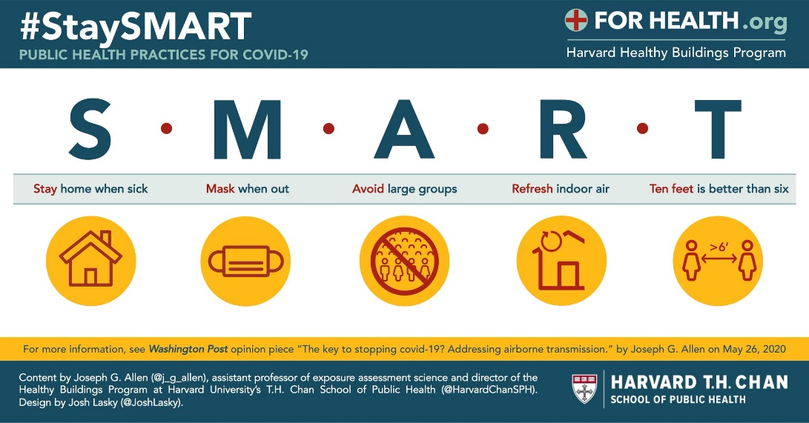
Figure 1.
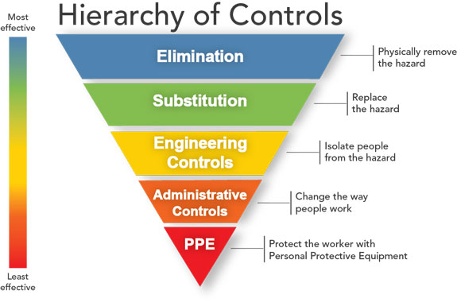

Source: https://www.cdc.gov/niosh/topics/hierarchy/default.html

Figure 2.
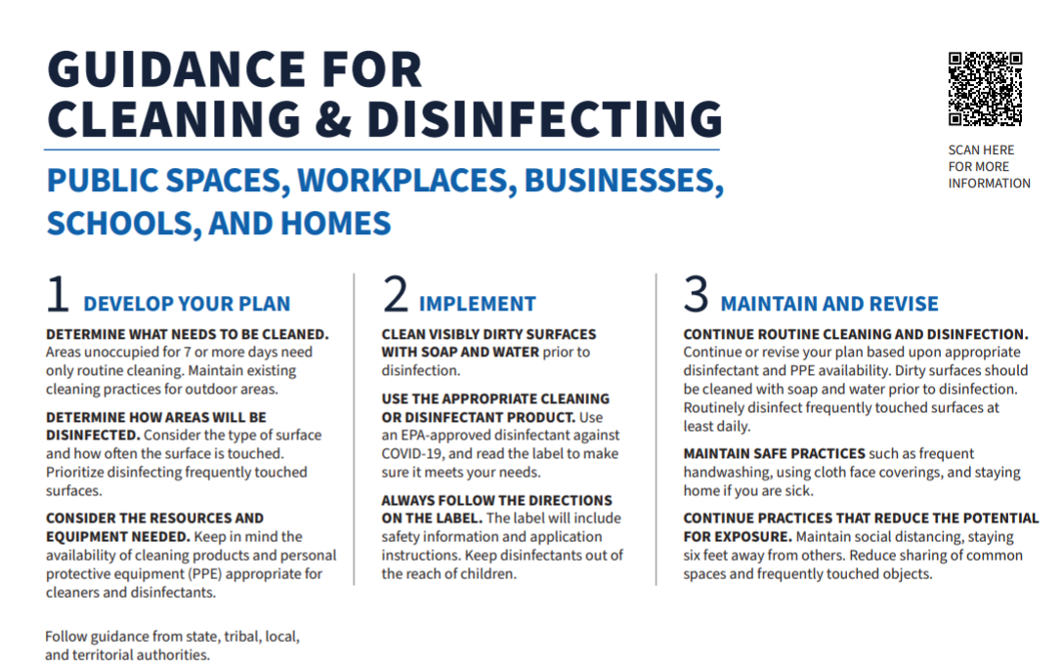

Figure 3.
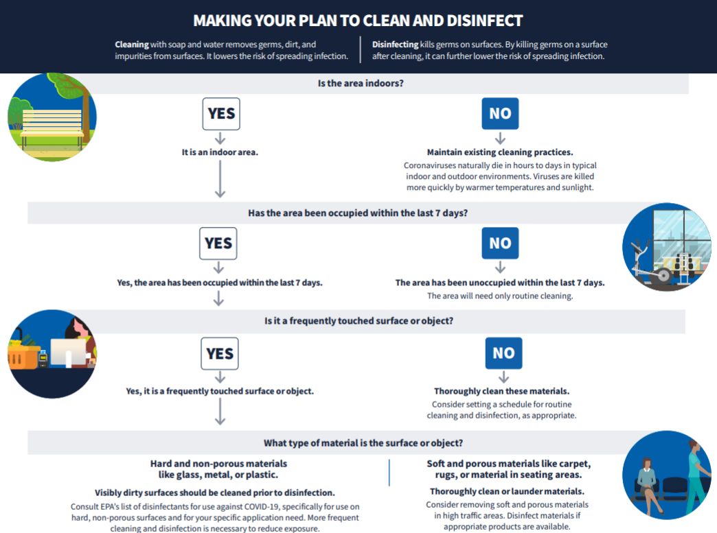

Table 1. Screening for Research Staff Prior to Field Work.
NOTE: This screening should occur each day that research staff member is scheduled to go into the field. Documentation of this screening should be kept as part of the study protocol. This is a minimum screening tool – other specific screening queries should be used as necessary. If a research staff member has any underlying conditions that might put them at risk, they should not go out into the field.
- Have you travelled to an area where community transmission is extremely high within the last 14 days?
- Have you attended a large gathering (more than 20 individuals) within the last 14 days?
- Have you been exposed to anyone who has tested positive for COVID-19 within the last 14 days?
- Have you had any of the following symptoms within the last 2 days?
  - Cough, shortness of breath, fever, loss of taste, loss of smell.

- If a staff member replies ‘YES’ for questions 1 & 2, they should have their temperature taken.
            - If the temperature is high (see below), the staff member cannot go into the field and should be referred for COVID-19 testing
            - If the temperature is normal, the staff member should be monitored for any COVID-19 symptoms.
- If a staff member replies ‘YES’ for questions 3 & 4, they cannot go into the field, and should be referred for COVID-19 testing.
- If the answers are “NO” to ALL the above questions:
      - Proceed to take the research staff member’s temperature.
        - If temporal artery temperature is 100.4° F (38° C) or higher, staff will not conduct study visit and provide participant information on contacting the local health department
Table 1.

Screening for Research Staff Prior to Field Work.

NOTE: This screening should occur each day that research staff member is scheduled to go into the field.

Documentation of this screening should be kept as part of the study protocol. This is a minimum screening tool – other specific screening queries should be used as necessary. If a research staff member has any underlying conditions that might put them at risk, they should not go out into the field.

1. Have you travelled to an area where community transmission is extremely | Yes |  | No
high within the last 14 days?
2. Have you attended a large gathering (more than 20 individuals) within
 | Yes |  | No
the last 14 days?
3. Have you been exposed to anyone who has tested positive for COVID-19 | Yes |  | No
within the last 14 days?
4. Have you had any of the following symptoms within the last 2 days?
 | Yes |  | No
• Cough, shortness of breath, fever, loss of taste, loss of smell.

- If a staff member replies ‘YES’ for questions 1 & 2, they should have their temperature taken.

- If the temperature is high (see below), the staff member cannot go into the field and should be referred for COVID-19 testing.

- If the temperature is normal, the staff member should be monitored for any COVID-19 symptoms.

- If a staff member replies ‘YES’ for questions 3 & 4, they cannot go into the field, and should be referred for COVID-19 testing.

- If the answers are “NO” to ALL the above questions:

  - Proceed to take the research staff member’s temperature.

    - If temporal artery temperature is 100.4° F (38° C) or higher, staff will not conduct study visit and provide participant information on contacting the local health department.

Table 2. Screening for study participants prior to measurement.
All study participants must be screened upon initial contact.
In the past 14 days, have you:
- Traveled internationally (if applicable)? Travel to other parts of the state/hot spots/any other states?
  - If yes to international travel (if applicable), did you travel to any of the countries listed on the CDC website with a Travel level 2 or 3 Health Notice?
- Had close contact (within approximately 6 feet) with a person who is under investigation for or confirmed to have COVID-19? If so, when was the last contact made?
- Had fever, and/ or cough, difficulty breathing, flu like symptoms, etc.?

  - If the answers to Q1 and Q2 are “YES”
    - Inform Study PI

  - If “YES” is answered to either Q3 or Q4:
- Inform the participant that their visit will be rescheduled for another time, after at least 14 days and/or after symptoms have resolved.
- Instruct participant to call the local health department
- Inform the study PI.

  - If the answers are “NO” to ALL the above questions:
    - Proceed to take participant’s temperature.
      - If temporal artery temperature is 100.4° F (38° C) or higher, staff will not conduct study visit and provide participant information on contacting the local health department

Table 2.

Screening for Study Participants Prior to Measurement.

All study participants must be screened upon initial contact.

In the past 14 days, have you:

1. Traveled internationally (if applicable)? Travel to other parts of the | Yes |  | No
state/hot spots/any other states?
• If yes to international travel (if applicable), did you travel to any of
 | Yes |  | No
the countries listed on the CDC website with a Travel level 2 or 3
Health Notice?
 | Yes |  | No
2. Had close contact (within approximately 6 feet) with a person who is
under investigation for or confirmed to have COVID-19? If so, when was the
last contact made?
3. Had fever, and/ or cough, difficulty breathing, flu like symptoms, etc.? | Yes |  | No

- If the answers to Q1 and Q2 are “YES”

  - Inform Study PI.

- If “YES” is answered to either Q3 or Q4:

  - Inform the participant that their visit will be rescheduled for another time, after at least 14 days and/or after symptoms have resolved.

  - Instruct participant to call the local health department.

  - Inform the study PI.

• If the answers are “NO” to ALL the above questions:

- Proceed to take participant’s temperature.

- If temporal artery temperature is 100.4° F (38° C) or higher, staff will not conduct study visit and provide participant information on contacting the local health department.

Table 3. Screening for Sites or Organizations Prior to Visiting
- Research staff will coordinate visit with site representative at least 10 days prior to visit.
- Site visit will be confirmed 2 days prior to visit
- One day prior to visit, research staff will call site and confirm:
- Is site accepting visitors?
- Have any clients, workers, children, or onsite staff reported fever, cough, difficulty breathing, flu-like symptoms, etc.?
- Have any clients, workers, children, or onsite staff tested positive for COVID-19?
- Is the site following any prescribed cleaning and safety procedures such as those from CDC?
- Are there any special precautions that you need us to follow?

  - If “YES” to 2 or 3:
    - Inform the site that we will not be visiting the site until at least 14 days and/or after symptoms have resolved or case was confirmed.
    - Inform the study PI.

  - If the answers are “NO” to 2 and 3 and “YES” to 1:
    - Minimum number of research team members needed may visit the site to conduct study visits.
    - Inform site that we will screen participants prior to study visit and follow-up after measurements, in case infections have been noted during that time.

  - If the answer is “NO” to 1:
    - Ask the site for current policy and anticipated date for allowing external visitors.
  - If the answer is “NO” to 4:
    - Probe to see if the current standards for cleaning and safety are appropriate. If not, consider rescheduling
  - Question 5 determines what type of precautions the research team must take before going on-site.

Table 3.

Screening for Sites or Organizations Prior to Visiting.

Research staff will coordinate visit with site representative at least 10 days prior to visit. Site visit will be confirmed 2 days prior to visit.

One day prior to visit, research staff will call site and confirm:

1. | Is site accepting visitors? | Yes |  | No
2. Have any clients, workers, children, or onsite staff reported fever, cough,
 |  | Yes |  | No
 | difficulty breathing, flu-like symptoms, etc.?
3. | Have any clients, workers, children, or onsite staff tested positive for
 |  | Yes |  | No
 | COVID-19?
4. Is the site following any prescribed cleaning and safety procedures such
 |  | Yes |  | No
 | as those from CDC?
5. Are there any special precautions that you need us to follow?
 |  | Yes |  | No

- If “YES” to 2 or 3:

  - Inform the site that we will not be visiting the site until at least 14 days and/or after symptoms have resolved or case was confirmed.

  - Inform the study PI.

- If the answers are “NO” to 2 and 3 and “YES” to 1:

  - Minimum number of research team members needed may visit the site to conduct study visits.

  - Inform site that we will screen participants prior to study visit and follow-up after measurements, in case infections have been noted during that time.

- If the answer is “NO” to 1:

  - Ask the site for current policy and anticipated date for allowing external visitors.

- If the answer is “NO” to 4:

  - Probe to see if the current standards for cleaning and safety are appropriate. If not, consider rescheduling

- Question 5 determines what type of precautions the research team must take before going on-site.

Project Name:
Project Director:
Date:
1. Initial Staff Training

 | Considerations | Details | Comments
 | COVID Transmission and Safety Protocols | Proper use of facemasks, social distancing, hand washing, PPE, etc.
 | Minimization of Transmission during research | Screening of staff prior to fieldwork
 | Interacting with data collection participants | Best practices for ensuring safe interaction for all involved
 | Assessing study site layout | specific rooms/areas where data collection will occur, which entrances/exits and restrooms will be used, which areas (if any) are off limits
 | Simulating active COVID-19 cases | What will the project do if they learn of active COVID-19 cases? Prior to going into field, while in field.
 | Document training | Date and time when training occurred

Resources:
- Example of Research Staff Training: Johns Hopkins training, see https://coronavirus.jhu.edu/covid-19-basics/protecting-your-health
- See https://www.osha.gov/SLTC/covid-19/controlprevention.html
- See OSHA COVID-19 for guidance: https://www.osha.gov/SLTC/covid-19/

2. Density Reduction

 | Considerations | Details | Comments
 | Research area should have adequate space between staff and participants | 6‘distance maintained but 10’ is best
 | Avoid high-density areas | Lobbies, classrooms, open cubicles, etc.
 | Consider dividing large research staff into teams | Teams will interact with smaller groups
 | Space audit for high-density areas prior to research | Monitor occupancy limits to ensure 6’ – 10’ distance. Consider alternative options – outside, group rotations, screens
 | Travel separately vs. carpooling

3. Local Faculty/Staff Symptom Surveillance, Self-Isolation, Contact Tracing, Referral
 | Considerations | Details | Comments
 | Research staff who have come in contact with a COVID+ case | Inform their supervisor and self-isolate for 14 days while working from home
 | Research coordinator responsible for monitoring COVID+ cases | Conduct contact tracing or referring out to a group
 | Prepare plans for identifying COVID+ staff members | Rapid implementation of stay-at-home orders
 | High-Risk Category staff should work from home | Those 65+ and/or with pre-existing conditions
 | Maintain HIPPA Regulations | Do not identify staff members who might have COVID-19

Resource:
- https://www.cdc.gov/coronavirus/2019-ncov/need-extra-precautions/index.html

4. Personal Protection Equipment (PPE)/Personal Hygiene

 | Considerations | Details | Comments
 | Masks | Required in all communal areas
 | Gloves | Disposable gloves should be available in all research spaces
 | Alcohol-based hand sanitizer ($>$60%) | Available in all communal areas
 | Infrared Thermometers | Temperatures $≥$ 100.4$℉$ should not go in to the field
 | Handwashing | Use soap and water for at least 20 seconds
 | Stay-at-home when sick prompts | Post signs in communal areas
 | Gowns/disposal caps/clothes | Remove/dispose after one use
 | Provide adequate PPE | Do not overstock for periods over 3 months
 | Systems in place | Cleaning PPE, disposing of waste, differentiate clean/contaminated areas, etc.
Resource:
- Donning/doffing video CDC recommendations for properly donning and doffing personal protective equipment

5. Environmental Maintenance (Office and Remote Locations)

 | Considerations | Details | Comments
 | Sanitizing Wipes ($>$60% alcohol)
 | Cleaning schedule | Routinely wiping down common areas, equipment, etc.
 | Ensure ADA Compliant when cleaning actions are in place

Resources:
- OSHA: https://www.osha.gov/SLTC/covid-19/controlprevention.html
- CDC: https://www.cdc.gov/coronavirus/2019-ncov/community/organizations/disinfecting-transport-vehicles.html

6. Screening Staff, Screening Study Participants and Organizations, and Testing

 | Considerations | Details | Comments
 | Questionnaire prior to research | Temperature checked, travel, gatherings, symptoms. Temperatures $≥$ 100.4$℉$ should not go in to the field
 | Individual visits for study participants | Screening/questionnaire should be assessed prior to visit. If exposed participants should be contacted after 14 day isolation period.
 | Visits to research sites/organizations | Screening/questionnaire should be assessed prior to visit. Sites should be contacted after 14 days to ensure no one was COVID positive at time of research
 | Home visits and/or community canvasing | Assess risk prior to visit, maintain social distancing, do not enter home, etc.
 | Determine degree of risk for community setting | Low, Medium, High, Very High
 | Determine “hot spots” | # of reported cases in research area; reported cases onsite (e.g., at a clinic or health center
 | Testing | Any staff member exhibiting symptoms should be tested with a repeat test every two weeks
 | Keep records of all questionnaires

7. Project Management

 | Considerations | Details | Comments
 | Ensure PPE supplies are available prior to arriving on site | Masks, wipes, disposable gloves, etc.
 | Have established cleaning protocol in writing and ensure all staff know individual responsibilities
 | Clean all equipment prior to leaving site
 | Ensure staff know protocol for applying/removing PPE for site visits.
 | Checklists for all parts of the research process | Place in Manual of Procedures or Standard Operating Procedures

Resources:
- CDC’s Guidance for Cleaning and Disinfecting site for recommendations.
- CDC recommendations for proper use of personal protective equipment (PPE)

8. Communication

 | Considerations | Details | Comments
 | Safety Standards and Procedures | Maintain updated procedures in Manual of Operations and Standard Operating Procedures
 | Update research staff on protocol changes regarding COVID
 | Inform study participants of safety protocols regarding minimizing COVID exposure
 | Inform community organizations of proper health and safety protocols | Both written and oral format

9. Research and Study Design Considerations

 | Considerations | Details | Comments
 | Approval for field work | Must obtain UTHealth CPHS approval to conduct research
 | Informed consent | Participants will be able to complete their study consent and PHI authorization forms online  http://go.uth.edu/SEMMxOnline  http://go.uth.edu/SEMMxPHI  http://go.uth.edu/SEMMxVerbal
 | Changes in Measures | Consider alternative options: interviews via WebEx, mail-in assessments, smaller groups, etc.
 | Privacy/Confidentiality Concerns | Verbal consent, recordings of WebEx sessions
 | Special Populations | Limited access to technology

UTHealth SPH Committee Members:
- Deanna Hoelscher, Chair
- Sarah Bentley
- Courtney Byrd-Williams
- Maria Fernandez
- Daphne Hernandez
- Steve Kelder
- Chris Markham
- Sheryl McCurdy
- Diane Santa Maria
- Lara Savas
- Carolyn Smith
- Jacob Szeszulski
- Alexandra van den Berg
- Jayme Wood, Support

